Deadlines

To member organisations in Europe
Dear colleagues,
In order to ensure effective preparation, transparent procedures, and smooth running of the meeting, the EI/ETUCE-Bureau has set the following deadlines for the 2009 EI Pan-European Conference / ETUCE General Assembly:
1. 15th September, 2009 Final date for guaranteed booking of hotel rooms
2. 9th October, 2009 Final date for nomination of Delegates and Observers
3. 9th October, 2009 Last date for applications for assistance
4. 23rd October, 2009 Submission of resolutions
5. 23rd October, 2009 Submission of nominations for President and Vice-Presidents
6. 23rd October, 2009 Submission of nominations for ETUCE General Secretary
7. 6th November, 2009 Submission of amendments to the proposed new By-Laws (Statutes)
8. 14.00 hours on 24th November, 2009 Urgent Resolutions
9. 14.00 hours on 24th November, 2009 Submission of nominations for Country seats on the Committee/Board
Please also note that no payments of dues will be accepted in Warsaw. The record of dues payments to be submitted to the Credentials Committee will be finalised on 18th November 2009.
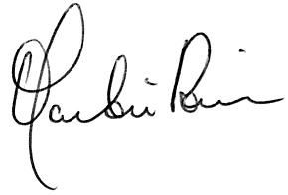

Martin Rømer  ETUCE General Secretary | Charlie Lennon  EI Deputy General Secretary
Candidates nominated for the election of President who are not elected to this position will automatically be nominated for the election of Vice-Presidents, unless they explicitly withdraw their nomination.
2 Candidates nominated for the election of Vice-Presidents who are not elected to a vice-presidency will need to formally submit their nomination prior to the proposed deadline if they wish to be nominated for a country seat.

