Confirmation of arrangements for the Conference
Final timetable
Monday, 26 November 2012
09.30 – 12.00 Women’s Caucus (EN-FR) –room 3
09.30 – 12.00 Higher Education Caucus (EN) – room 6
14.00 – 15.40 ETUCE Conference (EN-FR-DE-ESP-RU-HU) –room 5
15.40 – 16.10 Coffee break – Area 8
16.10 – 18.00 ETUCE Conference (EN-FR-DE-ESP-RU-HU) –room 5

Tuesday, 27 November 2012
09.00 –11.00 ETUCE Conference (EN-FR-DE-ESP-RU-HU) –room 5
11.00 – 11.15 Coffee break – Area 8
11.15 – 12.30 ETUCE Conference (EN-FR-DE-ESP-RU-HU) –room 5
12.30 – 14.30 Lunch – area 9
14.30 – 16.00 ETUCE Conference (EN-FR-DE-ESP-RU-HU) – room 5
16.00 – 16.15 Coffee break – area 8
16.15 - 17.30 ETUCE Conference (EN-FR-DE-ESP-RU-HU) – room 5

Wednesday, 28 November 2012
09.00 – 10.30 Conference (EN-FR-DE-ESP-RU-HU) – room 5
10.30 – 10.45 Coffee Break – area 8
10.45 – 12.30 Conference (EN-FR-DE-ESP-RU-HU) – room 5
12.30 – 13.00 Committee (EN-FR-DE-ESP-RU-HU) – room 5
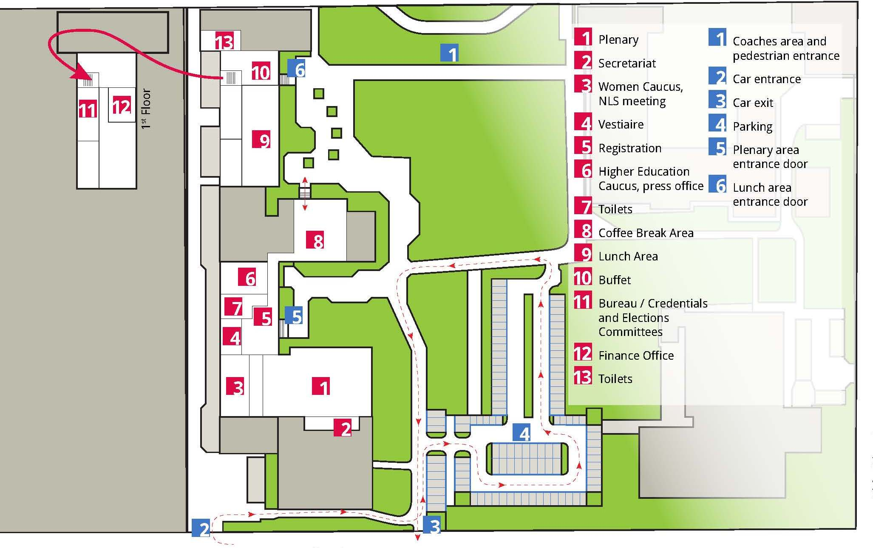
13.00 - … Lunch – area 9
Procedures
Resolutions
Urgent resolutions need to reach the secretariat prior to the opening of the conference. They can be sent to the Conference mailbox (ETUCEconference@csee-etuce.org)
Proposed amendments submitted in English within the deadline of 19 November will be compiled in a table that will be available on the conference web page in English only (http://pages.ei-ie.org/etuce-conference/index.php/en/ ) and in print at the registration area of the conference venue.
The resolutions as adopted (consolidated text) will be published on the web page in English. Other language versions of resolutions amended at the conference will be finalised after the conference.
Elections
The outcome of elections will be posted on the webpage and displayed in the registration area.
Nominations for country seats
The deadline for nominations for country seats will be announced in the plenary once the election of Vice-Presidents has been validated. The electronic version of the nomination form is available on the web page. Hard copies of the form will be available in the plenary at the greffiers desk. Forms completed on the spot are to be handed in at the greffiers desk. The list of nominations received will be regularly updated on the web page and displayed in the registration area.
Conference material
At registration, all participants will receive a bag including :
- The activity report
- A folder including all other documents
- A USB-stick containing all documents in five language versions, with the exception of the resolutions
- A voting card (delegates only)
- The latest edition of the ETUCE newsletter
Additional material available in the registration area :
- Overview of amendments to resolutions (in English only)
- A list of participants registered
- The list of credentials as approved by the Credentials’ Committee (available as from 1 p.m.)
- Print-outs of the present document
Please note that the secretariat has based the number of prints in the various languages on the preferences indicated by participants on registration. Should you prefer another language than the one indicated in your profile, you will be able to exchange your material into another language towards the end of the registration process, provided that that language version is still available.

Practical details
Transfers
Participants will be picked up and returned to the airport on arrival and departure.. When arriving at Budapest airport http://www.bud.hu/english, a driver will be waiting for you to bring you to your hotel. Please look for the following sign, in which EI and ETUCE logos as well as your names will be inserted.
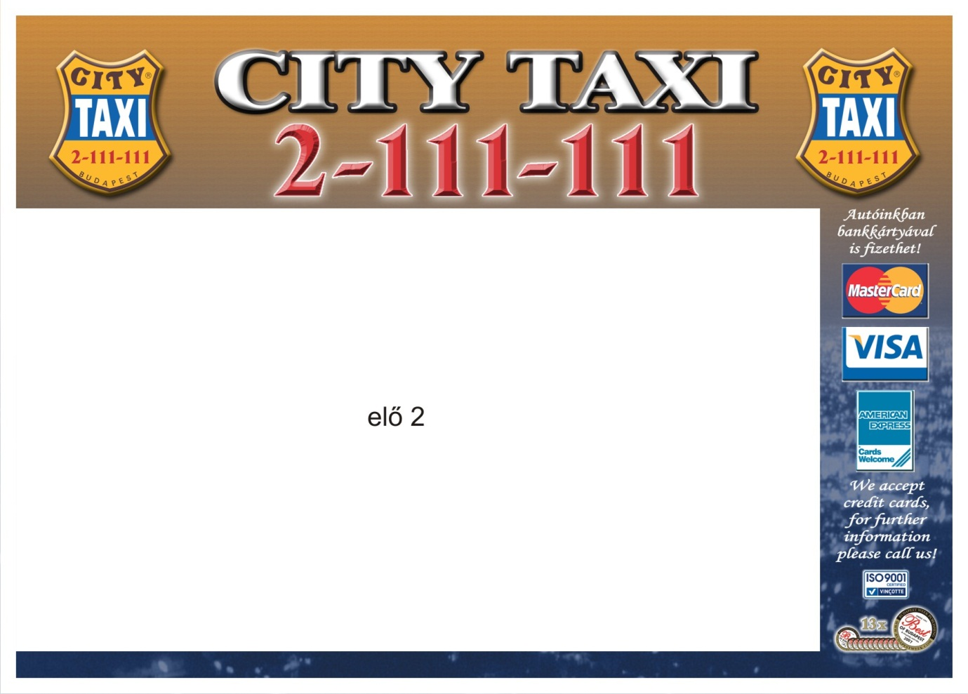
As for your departure from Budapest, an overview of scheduled taxi departures based on the information received will be displayed in the registration area. Transfers can be organised either from the conference venue or from your hotel. Please check the list put up and make sure the information is correct. Please inform the staff member in charge of transport issues (Victor Belaud) of any changes that might be required.
Transfers between the conference venue and hotels
Assisted delegates will receive tickets for the public transportation on check in in their respective hotels. Additional tickets are available in the finance office. Descriptions of itineraries are included in the practical information available on the webpage.

Interpretation in the meetings
How to obtain the head set?
- During the Conference plenary sessions there will be simultaneous interpretation into English, French, Spanish, German, Russian and Hungarian. During the Women’s Caucus interpretation will be provided into English and French. Each participant will require a ‘head set’ for purposes of listening to the interpretation services.

- Each ‘head set’ consists of ear phones and a receiver unit. The ‘head set’ receiver units must be recharged overnight. Therefore the ‘head sets’ must be issued and retrieved on a daily basis.

- ‘Head sets’ are expensive pieces of equipment, their average cost is approximately of €175. They are not usable for any other purpose. If any units are not returned, ETUCE will be held responsible. In these circumstances, arrangements have been made to identify the participant to whom each ‘head set’ is issued. The participant will be held responsible if the ‘head set’ is not recovered.

- In the badge holder which each participant will receive at Registration, there will be two identification badges. The first badge is to identify the participant and his/her status as delegate, observer or guest, and is used to gain entry to the Conference Sessions. The second badge is used to exchange on a daily basis for a ‘head set’ for interpretation purposes. This badge is clearly marked by a drawing of earphones. It mentions the participant’s name and organisation. When handing over this badge, the participant will receive the ‘head set’. The ‘head set’ is the participant’s personal responsibility. The badge will be placed in the storage holder of the ‘head set’ receiver which is issued to the participant and should be recovered at the end of each day when the ‘head set’ is returned for charging overnight. Each receiver is clearly identified by a unique number which is also to be found on its storage box.

Where to obtain the head set?
- Prior to the opening of the Women’s Caucus and the Conference, each day ‘head sets’ will be available for exchange against the second badge at the entrance to the Plenary. They can be taken from the Caucus to the plenary on the first day. Each receiver must be returned to the same storage space in the same box from which the receiver was obtained at the end of Congress sessions each day. The second badge must be recovered in order to obtain a new receiver on the following day. Staff will be available to assist with these tasks.

- If a ‘head set’ does not work or breaks down during the day, it must be returned to the storage box from which it was obtained and a new one issued. The identification badge will be transferred to the new storage space.

Your personal responsibility
- ‘Head sets’ may not be transferred to other participants. The identification badge in the storage space will be used to identify the person who received the ‘head set’ and that person will be held liable if it is not retrieved.

REQUEST: PLEASE ARRIVE EARLY TO OBTAIN YOUR HEAD SET. THIS WILL AVOID LONG QUEUES.
Festive dinner
Tickets for participants who signed up for the dinner will be available in the finance office. A limited number of tickets will be available for last-minute reservations. The address of the location is indicated on the tickets. Coaches will make a tour to pick up participants at the entrance of the four conference hotels booked by the secretariat (Lions Garden Hotel, Novotel, Ibis Hotel and Benczur hotel) between 7.00 and 7.25 p.m. Participants staying in other hotels will need to go to the nearest of these hotels to be picked up. Staff will collect tickets on arrival at the dinner venue, so please make sure to bring them with you. The dinner will start at 7.30 p.m.
Coaches will depart every half hour between 10.30 and Midnight. (last departure) to bring guests back to the four hotels.
Who can help you?
In the registration area of the conference venue, you will find a poster with pictures and names of staff members present on location, with an indication of their language skills and the issues on which they can be helpful. All staff is at your disposal to give assistance during the conference and to ensure your stay is enjoyable.
Video
Photographic and video material will be gathered at the ETUCE Conference and used for the purposes of internet, print or other media publication. If any conference participant wishes that no photographic or video material is taken of him or her during the course of the Conference, he or she must inform the ETUCE Secretariat in writing prior to start of the Conference. The ETUCE shall otherwise assume full consent of that person, and all other participants, to be filmed and photographed and to appear on the internet or in print or in other media publications.
Publications
In an effort to moderate the cost of transportation, a limited number of publications will be displayed for consultation.
You will find the samples for consultation in the press office, as well as an overview poster presenting all ETUCE & EI publications for the period 2010-12. Publications Order Forms will be made available. These orders will be dealt with after the Conference.

