Further and Higher Education Caucus
July 20th, 2015

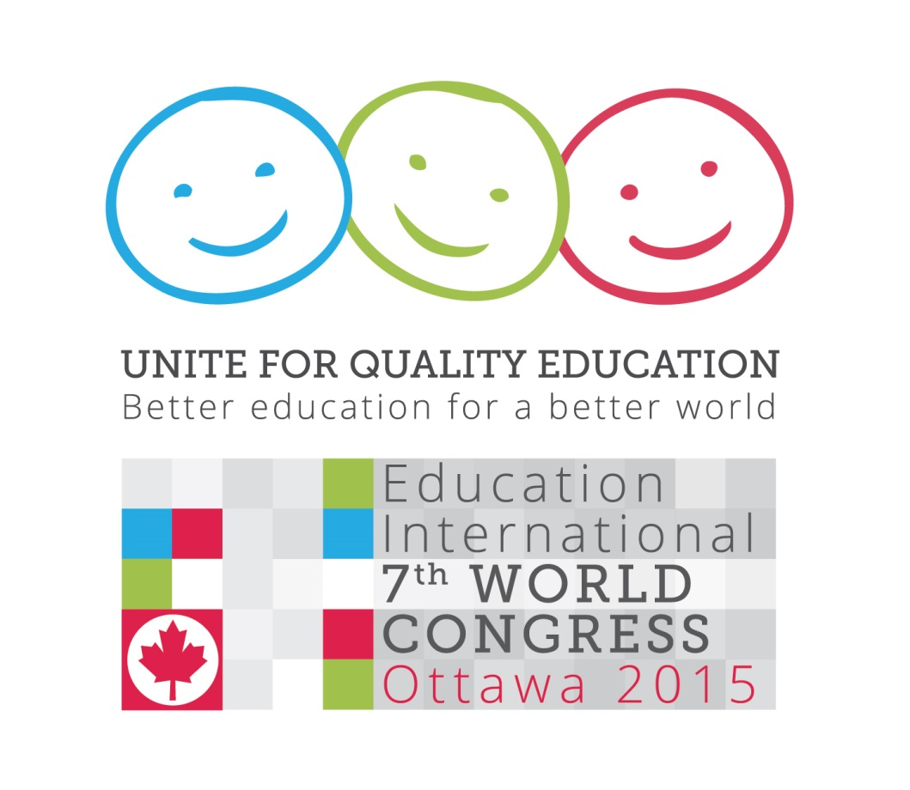

Agenda

09:00 – 09:30 Welcome and opening remarks
Susan Hopgood, President, Education International
09:30 – 10:45 Update: EI work programme in further and higher education
Chair: Grahame McCulloch, NTEU (Australia)
Presenter: David Robinson, CAUT/ACPPU (Canada)
10:45 – 11:00 Break
11:00 – 12:00 Development cooperation in further and higher education
Chair: Ingrid Stage, DM (Denmark)
Panelists: David Dzatsunga, COLAZ (Zimbabwe)
Yamile Socolovsky, CONADU (Argentina)
Amjad Dababat, PFUUPE (Palestine)

12:00 – 12:30 Overview of the afternoon roundtable discussions

12:30 – 14:00 Lunch

14:00 – 17:30 Roundtables

Roundtables, 14:00 – 17:30

Roundtable on VET
Room 206/208
Drawing upon the work of the EI Task Force on Vocational Education and Training, this session will focus on the major trends, debates, and controversies emerging in the sector. Topics to be considered include the impact of privatisation, the status of VET teachers and trainers, gender equity in VET, and “green” skills. Participants will be asked to identify research, policy, and campaign priorities for EI and its affiliates.

Opening Remarks: David Edwards, Education International

Panelists: Pat Forward, AEU (Australia)
Monique Fouilhoux, Education International
Christian Addai-Poku, NAGRAT (Ghana)
David Robinson, CAUT/ACPPU (Canada)

Fixed Term to Fair Term Employment in FHE
Room 212
This session will explore how FHE affiliates are confronting the challenges arising from the growing use and exploitation of staff employed on fixed-term contracts. Panelists will discuss strategies, tactics and tools to counter precarious employment in the sector, from legislative and regulatory responses to collective bargaining, organising, and campaigning. Drawing upon best practice cases, participants will be encouraged to consider what initiatives would be most applicable in their national context.

Chair: Sandra Grey, TEU (New Zealand)
Panelists: Marlis Tepe, GEW (Germany)
Caroline Senneville, FNEEQ-CSN (Quebec, Canada)
Elizabeth Lawrence, UCU (United Kingdom)

A. CONCLUSIONS OF THE 8TH EI HIGHER EDUCATION AND RESEARCH CONFERENCE
We, the participants in Education International’s 8th Higher Education and Research Conference, met in Buenos Aires, Argentina 25-27 September 2012 and reviewed the major trends and policy developments in our sector since the 7th Conference held in Vancouver, Canada in 2010. We express our sincere gratitude to our hosts CONADU for their warm welcome and generous hospitality.
NOTING the many challenges faced by higher education and research institutions, trade unions, staff and students in the current economic and political climate;
AFFIRMING that EI and its affiliates must step up efforts to defend and promote the professional, academic, trade union, and human rights of higher education teachers, researchers and staff; and
RECALLING EI policy that higher education and research is a public service and that it is the responsibility of public authorities to prevent the marketisation and trade in education and intellectual property, the casualisation of employment in the sector, the application of private-sector and for-profit management models to institutions, and the privatisation of provision;
Recommends to the EI Executive Board:
- Adoption of the Policy Statement on Tuition Fees asserting that tuition fees should not be charged and where they exist they should be progressively reduced and eliminated.
- Agreement to hold the 9th International Higher Education and Research Conference in the Africa region in 2014.
Recommends that the EI Secretariat:
- Collect and disseminate information and analysis of the impact of austerity measures on the higher education and research sector as part of the Education in Crisis campaign, paying particular attention to the impact on the terms and conditions of employment of staff, their professional status and academic freedom.
- Ensure that interventions with the World Bank, IMF, G-20 and other relevant multilateral organizations stress the social and economic importance of public investment in higher education and research, particularly in developing countries.
- Gather information from affiliates concerning the status of precarious and fixed-term employment in the sector, with a particular focus on early-stage researchers.
- Explore ways to facilitate greater information sharing amongst higher education and research affiliates, such as an electronic newsletter.
- Focus on strengthening EI’s membership in the Latin America, Africa and Asia-Pacific regions.
- Ensure higher education and research affiliates are represented in the EI Organisers’ Network.
- Continue efforts to oppose the commercialisation and privatisation of higher education and research, including lobbying against the coverage of education and related services in international commercial trade agreements such as the WTO’s General Agreement and Trade and Services, and the recently proposed International Services Agreement.
- Encourage and facilitate affiliates to promote equity for disadvantaged groups including women, indigenous peoples, racial groups, persons with disabilities, and lesbian, gay, bisexual, and transgendered persons.
- Engage with UNESCO, the World Bank and the OECD to highlight the negative consequences of international university rankings and assessments of student learning outcomes.
- Explore ways to promote greater development cooperation and international solidarity initiatives between higher education and research affiliates.
- Step up monitoring and reporting of violations of academic freedom, trade union rights, and civil liberties in the higher education and research sector.
Calls upon EI Affiliates to:
- Strengthen cooperation and sharing of information and best practices around campaigning, organising, collective bargaining, and promoting equity.
- Publicize and share good practice, including collective agreement language, legislative initiatives and public campaigns to improve the terms and conditions of employment of fixed-term staff and to promote paths for early stage researchers to permanent and continuing employment.
- Develop and strengthen partnerships with student organizations and other allies.
- Contribute to and actively participate in EI’s Education in Crisis campaign.
- Strengthen international solidarity and development cooperation initiatives.

B. Policy Statement on Tuition Fees

- Participation in higher education for all those who are qualified is a right enshrined in Article 26 of the United Nations Universal Declaration of Human Rights and in the 1967 International Covenant on Economic, Social and Cultural Rights:

Higher education shall be made equally accessible to all, on the basis of capacity, by every appropriate means, and in particular by the progressive introduction of free education.

- Higher education is a public good that benefits all of society by contributing to social, cultural, democratic and economic development.

- It is therefore the responsibility of states to promote and to guarantee the right to higher education by providing public funding that is sufficient to cover the full costs of education. Higher education is most equitably financed through public funding supported by a progressive income tax system.

- Tuition fees are private user fees that can distort the academic mission of higher education institutions by transforming students into consumers and teachers into service providers. The competition for fee-paying customers amongst institutions undermines the core instructional and research mission of the university and shifts resources into commercial marketing, fundraising, recruitment and public relations.

- Tuition fees have a disproportionately negative impact on women, minorities, indigenous peoples and economically-disadvantaged groups.

- The introduction of and increase in tuition fees have led to rising student debt. This has a negative social and economic impact. High levels of debt affect students’ decisions to enter socially important but underpaid occupations. Consequently, the primary form of direct student financial assistance, including living allowances, should be needs-based grants.

- In many jurisdictions international students are charged extraordinarily high tuition fees. This has a serious impact on the vast majority of students from less developed countries who are unable to afford these fees.

- Tuition fees should not be charged students. Where tuition fees exist, governments should commit to gradually reduce fees with the eventual goal of eliminating them in all sectors of higher education. Student financial assistance programs should provide opportunities for all academically qualified individuals to participate in higher education.

- Governments and institutions should ensure that all barriers to participation, including financial ones, are removed.

C. Conclusions of the 9th Higher Education and Research Conference

Education International’s 9th Higher Education and Research Conference met in Brussels, Belgium 10-12 November 2014 and reviewed the major trends and policy developments in our sector since the 8th Conference held in Buenos Aires, Argentina in 2012.
AFFIRMING that quality public higher education and research is a public good that can fulfill its role of preserving, transmitting and advancing knowledge only if there is adequate public funding, if institutions are free from outside pressures, and if academics enjoy academic freedom and decent terms and conditions of employment;
NOTING with alarm the rising number of precarious and casual positions that are poorly paid, provide few if any benefits, and offer little or no security or protection for the exercise of academic freedom; and,
RECALLING that it is the responsibility of public authorities to prevent the marketization, privatisation and trade in education.
Recommends to the EI Executive Board:
- Adoption of the Statement on MOOCs.

- Agreement to hold the 10th International Higher Education and Research Conference in the Africa region in 2016.

- Consider dedicated representation on the EI Board for the higher education and research sector.

Recommends that the EI Secretariat:
- Include in upcoming campaigns a focus on the problem of casual and fixed-term employment of higher education teachers, researchers and staff, highlighting the right to decent work, a living wage, and academic freedom.

- Ensure that EI’s interventions with UNESCO, ILO, the World Bank, IMF, OECD, G-20 and other relevant multilateral organizations stress the social and economic importance of public investment in higher education and research.

- Advocate for the inclusion of access to quality higher education as a central pillar in the post-2015 United Nations Millennium Development Goals.

- Continue efforts to oppose the commercialisation and privatisation of higher education and research, including lobbying against the coverage of education and other public services in international and regional commercial trade agreements such as the Trade in International Services Agreement, the Trans-Atlantic Trade and Investment Partnership, and the Trans-Pacific Partnership Agreement.

- Step up monitoring and reporting of violations of academic freedom, trade union rights, and civil liberties in the higher education and research sector.
Calls upon EI Affiliates to:
- Strengthen cooperation and sharing of information and best practices around campaigning, organising, and collective bargaining.

- Encourage and promote equity within unions and workplaces for disadvantaged groups including women, indigenous peoples, racial and ethnic groups, persons with disabilities, and lesbian, gay, bisexual, and transgendered persons.

- Undertake organising campaigns, where relevant and applicable, targeting fixed-term staff, early stage researchers, and education support personnel.

- Develop and strengthen partnerships with student organizations, other trade unions, community organisations and other allies to build strong and effective coalitions.

- Lobby governments to improve funding and to support the inclusion of access to quality higher education as a key element of the post-2015 Development Agenda.

- Urge institutions and governments to ensure greater recognition of the value of teaching in higher education by creating supportive teaching and learning environments for students and staff.

- Strengthen international solidarity and development cooperation initiatives, including participation in the EI Higher Education and Research Development Cooperation Consortium.

D. Policy Statement on MOOCs

Preamble
Massive open online courses, or MOOCs, represent the latest effort to harness new information and communication technologies to provide higher education. Supporters of MOOCs portray them as an inexpensive and innovative way of delivering content to a vast audience. Increasingly, some see the potential for profits to be made in selling MOOCs on a global scale.
Education International is dedicated to the removal of barriers that traditionally restrict access to and success in higher education. EI is also strongly committed to increasing equality and equity of educational opportunity for all qualified persons. MOOCs are just one medium that may allow higher education institutions to pursue these goals. Nonetheless, governments, institutions and private providers may also misuse MOOCs and other distance education technologies to promote privatisation, reduce public funding, and increase managerial control over academic staff.
EI asserts that the following principles must be used to guide the development and use of MOOCs and other technologically-mediated forms of higher education:
1. Higher education is a public good and a public service.
EI believes that education is a public good and a human right. MOOC’s should not be used to weaken public provision of education or promote the privatisation and commercialisation of public education.
2. Higher education should be accessible to all qualified persons.
MOOCs and other forms of on-line education may help increase access to higher education, but only if they are a supplement to and not a replacement for proven pedagogical practices. Many current MOOC offerings have large enrolments, but suffer from extraordinarily high drop-out rates compared to traditional face-to-face instruction. Access to higher education is meaningless if students are not successful.
3. Higher education should promote equity and reduce social disadvantages.
Evidence suggests that at-risk, minority and other disadvantaged students fare more poorly with MOOCs than with in-class instruction. In this way, MOOCs may increase rather than lessen inequality in educational outcomes. MOOCs also threaten to create two tiers of higher education: one in which privileged students get their own professor, and the other in which students watch videotaped lectures on a computer screen.
4. Governments have an obligation to ensure that higher education receives adequate public funding.
MOOCs should not be used as a way for governments to reduce public funding and cut instructional costs. In fact, the costs of producing high-quality MOOCs and other online courses are not often cheaper than face-to-face classes.
5. Higher education should be offered in ways appropriate to the needs of students and relevant to local context.
MOOCs to date are overwhelmingly a Western, Anglo-American effort and based upon a particular academic experience, knowledge base and pedagogical approach. The vast majority of courses are offered in English. MOOCs therefore may not provide courses relevant to local needs or sensitive to different knowledge systems and traditions. At an extreme, MOOCs may inhibit the development of local capacity and content, particularly in low- and middle-income countries.
6. Higher education teaching personnel should have the freedom to select and use teaching and support materials which they believe to be appropriate.
Academic freedom includes the right to teach without any interference, including the right to choose the content and methods of teaching, and the freedom to use or not to use any specific technique or technology. No higher education teacher should be forced to adopt or use MOOCs if s/he feels it is inappropriate.
7. Higher education teaching personnel should retain their intellectual property rights of course material no matter what the mode of delivery.
Currently, most MOOC providers establish a proprietary claim on material included in their courses, license the access and use of that material to the user, and exercise ownership over user-generated content. To fully exercise academic freedom, however, higher education teaching personnel should retain ownership of their course material, including material used in distance and on-line courses.

E. Report of the EI Task Force on Vocational Education and Training

1.0 Introduction

Following the adoption of 1.4.1 Resolution on New Impact of Vocational Education and Training in Each EI Region, and 1.4.2 Resolution on Vocational Education, Gender and Inclusiveness at the 6th EI World Congress in 2011, the Task Force was established to give advice and recommendations on how to move forward in the development of VET policy and advocacy.

2.0 Progress update

The task force has had two face-to-face meetings, one in January 2013 and one in May 2014. Vocational education and training has become more topical in recent years, and is today, together with skills development and employability, a central issue for the international institutions. However, these institutions seldom look at policy from a teacher perspective, and the task force has aimed to make the voices and terms and conditions of teachers more present in these debates.

EI actively participated in UNESCO’s 3rd International Congress on TVET in Shanghai, China in May 2012. The Congress focused on what TVET policy measures might be taken, particularly in difficult economic times, to facilitate learning and skills development. EI was invited to make two formal presentations at the event, one focusing on the need to develop stronger social dialogue and collective bargaining practices in the sector, and the second looking specifically at the precarious employment of TVET teachers, highlighting the need to improve the status and terms and conditions of TVET teachers in order to improve quality.

The Task Force has been following the revision of the UNESCO recommendation on Technical and Vocational Education and Training. It submitted extensive proposals in advance of the expert meeting that EI attended in May, 2014, and has continued to monitor and contribute to the process.

The Task Force continues to monitor VET developments within the OECD, and along with TUAC, and closely follows and intervenes in debates over PIAAC (Programme for the International Assessment of Adult Competencies) and the OECD Skills Strategy. The Task Force also analysed the EFA Global Monitoring Report 2012, Youth and Skills: Putting Education to Work, which looked at youth and skills and more specifically at how skills development can improve young people’s job opportunities.

Vocational education and training has also been covered in the UN-led processes around a new global development framework. Skills and skills development as well as youth employment, employability and skills for work have been high on the agenda in the different debates about an education agenda beyond 2015, and the task force has analysed the draft language of the proposals of the UN Open Working Group on Sustainable Development as well as the EFA Steering Committee.

The task force agreed to put together a number of papers to describe and analyse different trends and developments in the VET sector. These include the skills shortage, brain drain, privatization, and the recognition of qualifications and prior learning assessment.

3.0 Recommendations

In order to consolidate the progress made and move towards the full implementation of existing VET Resolutions, the Task Force has come up with the following recommendations for consideration by the Executive Board:

- EI should continue its work to raise the profile of vocational education and training, both internally and externally. As a step forward in this respect, the task force recommends that consider ensuring the Higher Education and Research Conference includes postsecondary/tertiary vocational education perspectives and participation;

- EI must continue to actively participate in the revision of the UNESCO Revised Recommendation on Technical and Vocational Education and Training, paying particular attention to the paragraphs on TVET staff as well as social dialogue;

- EI should more explicitly include VET issues in the Unite for Quality Education campaign and advocate for the inclusion of VET in the post-2015 agenda;

- Privatisation is one of the main challenges for the VET sector worldwide and EI should ensure a VET perspective in all of its work on privatisation, and the political economy of education. Moreover, EI is asked to examine, expose and track the international/multinational companies that provide VET across the globe;

- Issues surrounding VET must be included and reflected in EI’s work on trade and globalisation, including the TTIP and TPP;

- The status of VET teachers should be given particular attention within the context of the 2015 meeting of the Committee of Experts on the Application of the Recommendation concerning Teachers (CEART);

- Further work should be done on ICT in VET; gender and inclusiveness; adult education and training; “green skills” and “just transition” to low carbon jobs; and workplace learning and apprenticeships;

- Following the successful VET Forum held during the Cape Town Congress in 2011, EI should ensure that there is space for a VET Policy Forum at the upcoming Congress, where all affiliates active in the field can gather to discuss topical issues, survey regional developments and agree on action plan;

- In order to guarantee that EI continues to have a strategic and coordinated approach to VET and respond to new developments in the sector, the mandate of the VET task force should be extended.

