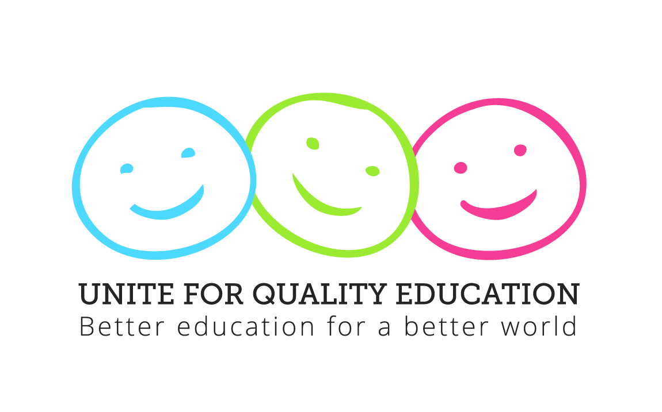

Unite for Quality Education Conference
Montreal, Canada
27th – 30th May, 2014

Concept Note

Background

On 4 October 2013, Education International (EI) launched its Global Action Year in Paris and New York. The theme for EI’s mobilisation initiative is "Unite for Quality Education - Better Education for a Better World."

Through this initiative, EI and its member organizations will be calling for the achievement of the highest quality of education for all, in each country and for quality education to remain at the top of the agenda for a sustainable, peaceful and prosperous future, including the post-2015 development agenda. This mobilisation will run for a year, from World Teachers’ Day 2013 to World Teachers Day 2014. It will involve all EI member organisations throughout the world, and organizations with similar aims, together in a concerted effort to highlight the importance of high quality education to the future of individuals and society. The three pillars of the Unite for Quality Education campaign are:

• universal and free access to quality teachers;
• modern teaching tools and resources; and,
• supportive and safe environments for teaching and learning.

The Global Education Conference will provide an opportunity for EI member organisations and organisations with similar aims to join forces for quality education for all.

Aim and objectives of the conference

The aim of the conference is to create a platform for EI member organisations and education partners to join forces around a shared vision of quality education, with quality teachers, tools and resources and safe and supportive teaching and learning environments at its core. The specific objectives of the conference are:

- To discuss strategies for promoting free access to quality education;
- To discuss measures for improving teaching quality and motivation, including teacher training, professional development and support;
- To debate the role of modern tools and resources in achieving quality education;
- To identifying measures for creating supportive, safe and healthy school environments; and
- To review progress towards the achievement of Education for All (EFA) and Millennium Development Goals (MDGs) and share strategy on how to ensure the inclusion of free quality education for all in the post-2015 global education strategy.

Format
A debate on future challenges to education, including the transformation of education in a digital society , the future role of teachers, our response to the ever changing social environment and the role of teachers and their unions in education policy development. The conference will comprise presentations, panel debates, and parallel breakout working sessions.
Setting: A classroom setting led by a ‘teacher’ as moderator and panelists as ‘students’ for the plenary panel debates is proposed. The stage will have a backdrop depicting the class/staff room.

Participation
The conference will bring together representatives of EI member organisations and education partners, including OECD, UNESCO, GEFI, GCE and other UN agencies and civil society organisations.
Expected number of participants: 300

General overview of the conference week:
Preliminary activity: Monday 26 May:
09:00 – 12.00 EI Officers’ Meeting
12:30 – 14.00 Press briefing/ComNet meeting?
14:00 – 16:00 CTG/La Francophonie meeting?
16:30 – 18.00 OECD Advisory Committee
Global Education Conference:
Tuesday 27 May - EI OECD Conference
Wednesday 28 May /Thursday 29 May - Unite for Quality Education Conference

Post-conference: Friday 30 May - Strategic Planning for World Action Day

DAY 1: EI OECD Conference Tuesday, 27 May 2014

09:00 – 09:15 Welcome-Susan Hopgood
09:15 – 09:30 Introduction: Plenary- Fred Van Leeuwen
09:30 – 10:30 Plenary- OECD, Achieving equity and Inclusion in Public Education Systems- the Conditions for High Quality Teaching in the 21st century. (EI OECD Advisory Committee to advise on speakers)
10:30 – 11:00 Plenary Panel. Discussants- OECD,CTF, EI.
11:00 - 11:30 Coffee break
11:30 – 12:30 Breakout sessions with concrete recommendations
12:30 – 14:00 Lunch
14:00 – 14:30 Plenary – An invited non OECD speaker
14:30 – 15:30 Plenary Panel. Discussants; to be decided.
15:30 – 16:00 Coffee break
16:00 – 17:00 Breakout sessions with concrete recommendations
17:00 – 17:30 Closing
18.00 – 19.30 Reception

DAY 2: Unite for Quality Education Conference Wednesday, 28 May 2014
09:00 – 09:30 | Session 1: Opening  -Opening remarks by EI President  -Welcome remarks by CSQ President  -Welcome remarks by Mayor of Montréal  -Welcome remarks by the Prime Minister of Quebec
09:30 – 10:15 | Keynote address  -UN Secretary General/Director General of UNESCO (TBC)  Questions and comments
10:15 – 10:30 | Unite 4 Quality Education: Video of the campaign to-date
10:30 – 11.00 | Coffee/Tea Break
11.00 – 12.30 | Panel Debate Topic 1: Education governance: The challenge of providing and financing Quality Education  Moderated by: ?  Brief introductory statements:  Panelist 1 (Proponent of privatisation e.g. World Bank, Pearson Foundation or GEMs)  Panelist 2 (Strong proponent of education that is publicly provided, financed, and managed)  Panelist 3 (Academic)  Questions, comments and recommendations
12.30 – 14:00 | Lunch
14:00 – 15:30 | Panel Debate Topic 2: Education for global citizenship  Moderated by: ?  Brief introductory presentations:  Panelist 1 (UNESCO/GEFI representative)  Panelist 2 (Union or student representative)  Panelist 3 (UN Secretary General’s Office - Amina Mohammed)  Questions, comments and recommendations
15:30 – 16:00 | Coffee/Tea Break
16.00 – 18.00 | Break-out sessions
Break-out session 1: Quality teaching
Strategies for promoting quality teacher education and development
Break-out session 2: Quality teaching and learning tools, materials and technology
How can appropriate curricula and inclusive teaching and learning materials and resources be ensured for all?
Break-out session 3: Quality supportive and safe environments for teaching and learning
Creating healthy and safe school environments for effective teaching and learning
Break-out session 4: Training session: Advocacy on post-2015 education strategy and the future of education
UN processes around global development and education goals, emerging priorities and opportunities for education union engagement
18:00 – 20:00 | Cocktail hosted by CSQ and other Quebec affiliates

DAY 3: EI/UNESCO/GEFI Conference Thursday, 29 May 2014
09:00 – 10:30 | Panel Debate Topic 3: Inclusive education: strategies for achieving equitable participation in education for a just society  Moderated by:?  Brief introductory presentations:  Panelist 1 (Gender advocate)  Panelist 2 (Indigenous groups)  Panelist 3 (Disabilities – Inclusion International?)  Questions, comments and recommendations
10.30 - 11.00 | Coffee/Tea Break
11:00 – 13:00 | Break-out sessions
Break-out session 1: Quality teaching
Strategies for attracting and retaining quality teachers
Break-out session 2: Quality teaching and learning tools , materials and technology
The role of ICT in education
Break-out session 3: Quality supportive and safe environments for teaching and learning
The critical role of education support personnel in ensuring quality education
Break-out session 4: Training session: Advocacy on post-2015 education strategy and the future of education
Developing union advocacy strategies to ensure that the voice of educators is represented in the global development debate and equitable quality education is guaranteed beyond 2015?
13:00 – 14:30 | Lunch break
14:30 – 15:30 | Keynote presentation: The role and purpose of education in the 21st century  -Diane Ravitch (TBC)  Questions, comments and discussion
15:30 – 16:00 | Coffee/Tea Break
16:00 – 16:50 | Brief reports from Break-out sessions, conclusions and recommendations
16:50– 17:00 | Moving forward with the Unite for Quality Education campaign  EI General Secretary

EI Member Organisations ONLY:
DAY 4: Strategic Planning for World Action Day Friday, 30 May 2014

09.30 – 13.30 Planning for World Action Day - 5th October, 2014

09:30 – 10:00 Introduction
10:00 – 12:00 National Activities by Region
(11:00 – 11:30 Coffee)
12:00 – 12:45 Coordination and Support
12:45 - 13:30 Summary and Conclusions

