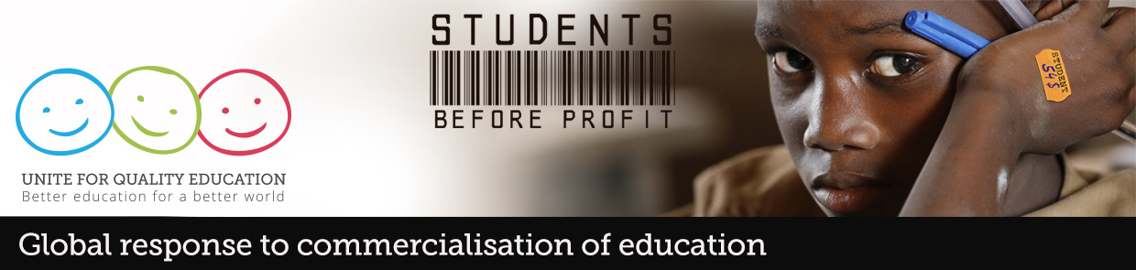
Mission Report

ACTIVITY:
GR Planning meeting- Focus Country: Kenya
Nairobi, 24-26 January 2016

HOST ORGANISATIONS:
Kenya National Union of Teachers (KNUT), Universities Academic Staff Union, Kenya Union of Post Primary Teachers (KUPPET)
OTHER PARTICIPANTS:
East African Centre for Human Rights (EACHRights); Economic and Social Rights Centre (Hakijamii); Action Aid-Kenya; International Commission of Jurists – Kenya Chapter; Katiba Institute; Global Initiative for Economic, Social and Cultural Rights (GIESCR); Transparency International – Kenya, Education International

BRIEF DESCRIPTION:

- OBJECTIVES

The purpose of the meeting was to review and enhance national strategies in response to the growing commercialisation and privatisation in/of education by

  - Strengthening participants’ understanding of the rationales for the commercialisation of education in Kenya with a particular focus on the rapid proliferation of corporate-backed for-profit schools such as Bridge International Academies;
  - Providing participants with the analytics tools to challenge assumptions around equity, efficiency, effectiveness and affordability of these ‘low-cost’ private schooling initiatives;
  - Analysing legislative and regulatory loopholes undermining teacher working conditions and the achievement of quality inclusive and equitable education for all;
  - Using the Education 2030 to advocate against the promotion of privatisation agendas and continue to campaign for the right to free, quality education;
  - Developing evidence-based advocacy strategies around key messages;
  - Supporting collaboration between education unions and civil society organisations through joint discussions. Mapping out future activities to further build a coordinated strategy around shared objectives;
  - Organising a public/media event to disseminate key messages and generate a public debate on “low fee” for-profit private schools

- ACTION

The 2-day workshop consisted of a series of conceptual presentations, group work sessions and plenary debates that focused on advocacy and communications planning aimed at countering the influence of private actors in education where it impacts negatively on educational access and exacerbates inequities. The challenges presented by commercialisation were analysed through the prism of the SDGs and in particular the fact that the SDGs can’t be achieved in the absence of clear political/legislative will on the part of governments (PP presentation here).

Through a case study participants discussed the implications of commercialisation of education for teachers’ working conditions and the perpetuation of inequalities in educational access and equity. This led to the development of a joint statement by EI’s affiliates and civil society organisations regarding the proliferation of corporate-backed for-profit schools in Kenya ie. Bridge International Academies.

The statement was released on 26th January at a highly succesful breakfast media event attended by representatives of the Minister and education authorities, MPs, the National Parents’ Association, civil society organisations and EI affiliates.

- MEDIA COVERAGE

As a result of the extensive media coverage generated, the education minister made an impromptu visit to a Bridge Academy School. Clip of his visit here

Some national media coverage:

KNUT on privatization of education (Standard Media)
Teachers' unions want low-cost slum schools closed (Daily Nation)
Bridge schools 'not registered' since 2009 (The Star)
Knut warns over informal schools rise (MediaMax-TV)

In addition to the social media traffic generated (check @sossionsgKNUT and @AGavrielatos, #unite4ed, #studentsbeforeprofit), Bridge CEO and co-founder Shannon May reacted with an article that was responded by KNUT General Secretary Wilson Sossion op-ed here

Diane Ravitch also wrote about the Kenya action in her blog.

- EVALUATION

Following an evaluation of previous workshops, a new approach was adopted for this mission. Firstly, the planning was built around the analysis of a comprehensive case study focusing the attention of participants on 3 key points of discussion:

- A political analysis of the conditions (political/economic/legislative) which contribute to the commercialisation of education;
- The need for clarity when developing an alternative narrative and related communications strategy;
- The importance of a focused and strategic national action plan.

The other new dimension was the inclusion of a public/media event as part of the 3-day evaluation and planning meeting. Whilst not always easy to achieve in the absence of an obvious hook, insisting on a public/media event is important for the following reasons: Firstly, it takes the discussion/debate outside the four walls of closed meetings into the public domain, regardless of media pick up; Secondly, it contributes to capacity building as there are always lessons learnt –logistical and political-when organising such events and thirdly, it deepens alliances and builds unity around a common purpose. The public / media events also allow us to generate international solidarity through traditional and social media.

It’s important to note that this mission contributed significantly to building more trusty and unity between our Members Organisations, particularly between KNUT and KUPPET where relations have been quite strained in the past. In contrast to the previous mission, KUPPET actively participated in all sessions including the public/media event.

http://www.periglobal.org/role-state/news/united-nations-and-african-commission-human-and-peoples%E2%80%99-rights-worried-about-commer

