ETUCE Special Conference

Vienna, 26-27 November 2014

GENERAL INFORMATION

INFORMATION ABOUT AUSTRIA

General information on Austria can be found here: http://europa.eu/about-eu/countries/member-countries/austria/index_en.htm

Electrocity
Electrical ratings: 230 Volts/ 50 Hz
Plugs :

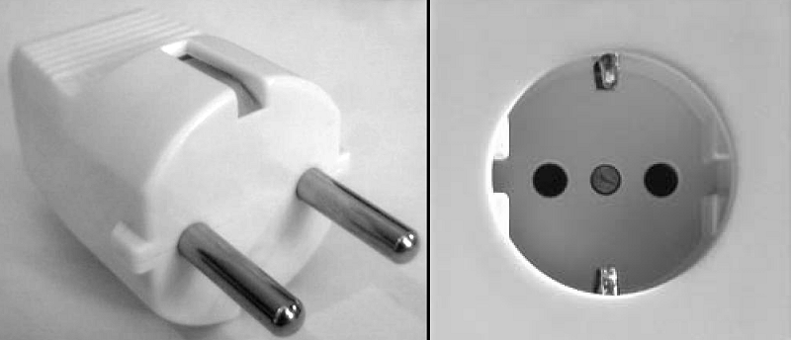

Water quality
Tap water in Vienna is generally safe to drink.

Smoking
The no-smoking policy in Austria states that smoking is generally prohibited in public institutions/ buildings and businesses where food and/or beverages are served. It basically prohibits smoking in restaurants and bars but there are some exceptions. Restaurants and bars may have designated smoking sections if they meet the same requirements as applied to public institutions. Small businesses no larger than 50 m² may decide for themselves whether or not guests are allowed to smoke.

CURRENCY

The local currency is the Euro (€)
Current currency rate can be found here : http://ec.europa.eu/budget/contracts_grants/info_contracts/inforeuro/inforeuro_en.cfm

LOCAL TIME

GMT + 1 hour UTC/GMT +1 hour (the same time as in Brussels)

INFORMATION ABOUT VIENNA

The Official Tourist Portal of Vienna will provide you with all the necessary information to learn about the city: http://www.austria.info/us/austria-pop-up-store/vienna-tourist-office-1568347.html

TRAVEL TO VIENNA

Information on Vienna airport can be found here : http://www.viennaairport.com/en/passengers
A wide variety of companies if offering flights to Vienna from destinations throughout Europe. The list of these companies with their respective websites is added here :

Adria Airways | www.adria.si
Aegean Airlines S.A. | www.aegeanair.com
Aer Lingus | www.aerlingus.com
Aeroflot | www.aeroflot.ru
Air Baltic | www.airbaltic.com
Air Berlin | www.airberlin.com
Air Europa Lineas Aereas, S.A. | www.aireuropa.com
Air France | www.airfrance.at
Air Malta | www.airmalta.com
Air Mediterranee | http://www.air-mediterranee.fr
Air Moldova | www.airmoldova.md
Air One | https://flyairone.com/EN-EU/
Air VIA Bulgarian Airways | www.air-via.com
AirSERBIA | http://www.airserbia.com
Alitalia | www.alitalia.com
Arkia - Israeli Airlines Ltd | www.arkia.com
B&H Airlines | www.bhairlines.ba
Belavia | www.belavia.by
Belle Air | http://www.belleaireurope.eu
Belle Air Europe | http://www.belleair.it
BH Air | http://www.bhairlines.com/
Blue Air | www.blueairweb.com
Britannia Airways Limited | http://flights.thomson.co.uk/en/index.html
British Airways | www.britishairways.com
Brussels Airlines | www.brusselsairlines.at
Bulgaria Air | www.air.bg
C.A.I. First | http://www.alitalia.com/gb_en/
Cirrus Airlines | www.cirrusairlines.de
Condor Flugdienst GmbH | http://www.condor.com/
Continental Airlines, Inc. | www.continental.com
corendon airlines | www.corendon-airlines.com
Corse Air International | www.corsair.fr/flight/home
Croatia Airlines | www.croatiaairlines.com
CSA Czech Airlines | www.czechairlines.at
Cyprus Airways | www.cyprusair.com
Danube Wings | www.danubewings.eu
Delta Air Lines | www.delta.com
easyJet | www.easyjet.com
Estonian Air | www.estonian-air.com
EuroLot | www.eurolot.com
Finnair | www.finnair.com
Freebird Airlines | www.freebirdairlines.com/
Georgian Airways | www.airzena.com
German Sky Airlines | www.germanskyairlines.de/
Germania Fluggesellschaft mbH | http://www.flygermania.de
Germanwings | www.germanwings.com
Iberia | www.iberia.at
InterSky | www.intersky.biz
Jet Air | www.jetair.pl
Jet Time | http://www.jet-time.dk
Jet2.com | www.jet2.com
Job Air | www.flycca.cz
KLM Royal Dutch Airlines | www.klm.at
LOT - Polish Airlines | www.lot.com
Lufthansa | www.lufthansa.com
Luxair | www.luxair.lu
Minoan Air | www.minoanair.com
Montenegro Airlines | www.montenegroairlines.cg.yu
NIKI | www.flyniki.com
Norwegian Air Shuttle A.S. | www.norwegian.no
Olympic Air | www.olympicair.com
Pegasus Airlines | www.flypgs.com
Peoples Viennaline | www.peoples.ch
Qantas Airways | www.qantas.com
Rossiya Airlines | www.rossiya-airlines.com
SAS Scandinavian Airlines | www.flysas.at
Sky Airlines | www.skyairlines.net
Sky Taxi | www.skytaxi.aero
SkyWork Airlines | http://www.flyskywork.com
SunExpress | www.sunexpress.com
SWISS | www.swiss.com
TAP - Air Portugal | www.flytap.com
TAROM | www.tarom.ro
thomas cook airlines | www.thomascookairlines.co.uk
Transaero Airlines | www.transaero.ru
transavia.com | http://www.transavia.com
TUI Fly | www.tuifly.com
Turkish Airlines | www.thy.com
Tyrolean Airways | www.austrian.com
Ukraine International Airlines | www.flyuia.com
United Airlines, Inc. | www.united.com
Ural Airlines | www.uralairlines.ru/en/
Vueling Airlines SA | www.vueling.com
XL Airways France | http://www.xlairways.fr

International buses
Buses from Vienna Airport to destinations in Slovakia, Hungary and the Czech Republic are summarised below.

Country | Destinations | Bus line | Timetable
Slovakia | Bratislava | Eurolines
Slovakia | Bratislava | Postbus
Slovakia | Prešov, Košice | Eurobus
Hungary | Budapest, Györ | Eurolines
Hungary | Budapest, Györ | Orangeways
Czech Republik | Brno, Prag | Student Agency
Czech Republic | Brno | Tourbus

TRANSFER FROM/TO THE AIRPORT

Vienna International Airport is about 16 km east of Vienna. The city centre can be reached quickly and in comfort by public transport.
To and from the airport by City Airport Train/ CAT
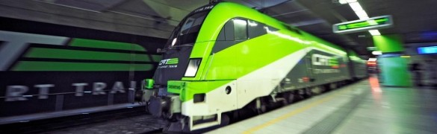
The CAT takes just 16 minutes nonstop to get from central Vienna to the airport and vice versa.
Central
The City Airport Train operates daily from 05.36 a.m. to 23.36 p.m. The City Air Terminal is just 10 minutes from St. Stephan’s Cathedral at Wien Mitte station, which can be reached easily by tram, underground, bus or taxi.
Comfortable
The City Airport Train offers a comfortable and relaxing journey in the double-decker carriages with jet environment and first-class seats. During the journey monitors provide interesting background and online information about departures and arrivals.
The table below gives an overview of the timetable.
Depart. | Arrival | First train (departure) | Last train (departure) | Duration
Wien Mitte | Vienna Airport | 05.36 (then 06 and 36 min past the hour) | 23.06 | 16 min
Vienna Airport | Wien Mitte | 06.06 (then 06 and 36 min past the hour) | 23.36 | 16 min
Price (single): € 12.00
A separate CAT counter is located in the arrivals hall, where you can obtain information about all CAT services, purchase a ticket and much more.
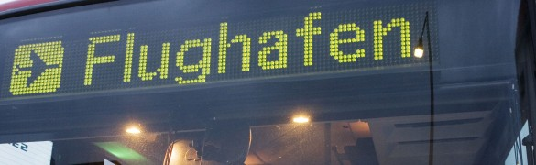
Regional buses
Vienna Airport Lines (Postbus) connects Vienna Airport with the main Vienna transport hubs.
The 3 Vienna Airport Lines routes serve all of Vienna's underground railway lines and also "Wien West" and "Wien Meidling" railway stations. Buses to the city centre (Morzinplatz/Schwedenplatz) run 24 hours a day, journey time just 20 minutes.
The following table provides a summary of the main regional bus connections.
Bus connections | Bus line | Duration | Timetable
Wien Morzinplatz/ Schwedenplatz | Vienna Airport Lines | 20 min
Wien Donauzentrum (via VIC) | Vienna Airport Lines | 40 min
Wien Westbahnhof (via Meidling Hbf.) | Vienna Airport Lines | 45 min
Wien Erdberg (VIB) | Eurolines | 15 min
Enzersdorf/Fischa (via Fischamend) | Postbus | 25 min
Neusiedl a. See (via Bruck/Leitha) | Postbus | 45 min
Prices (single): from € 8.00 for Vienna Airport Lines

HOTEL

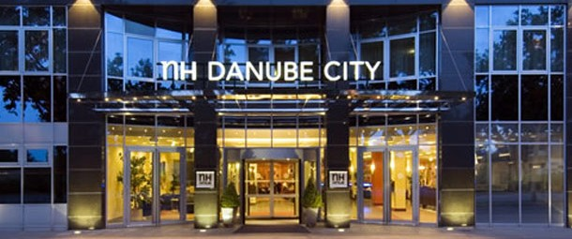
The ETUCE Secretariat negotiated preferential rates and made block bookings in the following hotels :

http://www.nh-hotels.de/nh/de/hotels/osterreich/wien/nh-danube-city.html?nhagentid=11009&nhsubagentid=110095220109&utm_source=google&utm_medium=maps&utm_campaign=googleplaces
Wagramer Strasse 21.
1220 Vienna
Tel. +43 1 260 200

Check-in time : 3.00 p.m.
Check-out time 12.00 a.m.

Rate single room (including breakfast and taxes): 125,- €
Rate double/twin room (including breakfast and taxes) : 145,- €

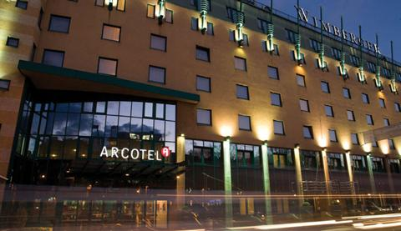
http://www.arcotelhotels.com/en/kaiserwasser_hotel_vienna/
Wagramer Strasse 8.
1220 Vienna
Tel. +43 1 224 24-0

Check-in time : 2.00 p.m.
Check-out time 12.00 a.m.

Rate single room (including breakfast and taxes): 119,- €
Rate double/twin room (including breakfast and taxes) : 139,- €

VENUE

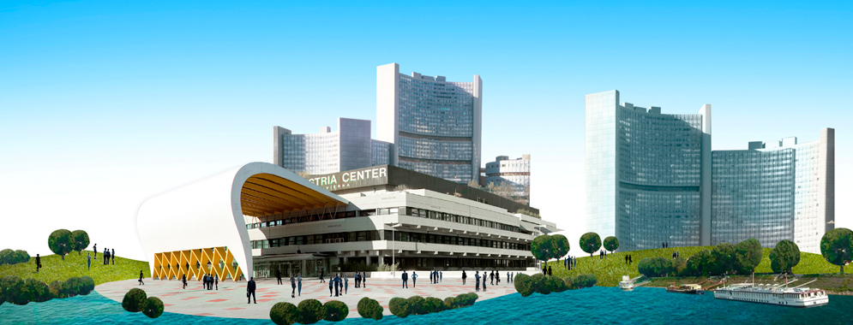

Austria Center Vienna
IAKW - AG
Internationales Amtssitz- und Konferenzzentrum Wien, AG
Bruno-Kreisky-Platz 1
A-1220 Wien
Tel.: +43-1- 260 69-0
Fax: +43-1-260 69-303

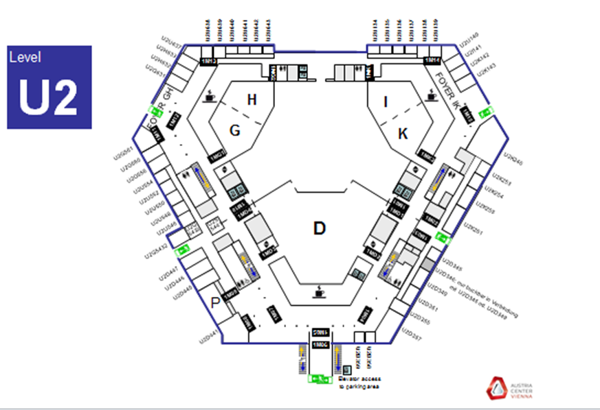

Monday 24/11 | Meeting | Room
12.00 - 14.00 | Registration Special Conference | Lobby D
14.00- 17.30 | ECE Conference | U2IK
Tuesday 25/11
09.00 - 12.30 | ECE Conference | U2IK
10.00 - 12.00 | CEE Network | U2H
13.30 - 15.00 | Crisis workshop | U2IK
15.00 - 18.00 | Registration Special Conference | Lobby D
15.00 - 16.30 | Higher Education Workshop | U2H
16.30 - 18.00 | Equal Opportunities workshop | U2IK
Wednesday 26/11
08.00 - 09.30 | Registration Special Conference | Lobby D
09.30 - 17.30 | ETUCE Special Conference | U2D
Thursday 27/11
09.00 - 12.30 | ETUCE Special Conference | U2D
09.30 - 11.00 | Break out session | U2H
09.30 - 11.00 | Break out session | U2K246

Austria Center Vienna is located at a 7 minutes’ drive from the city centre

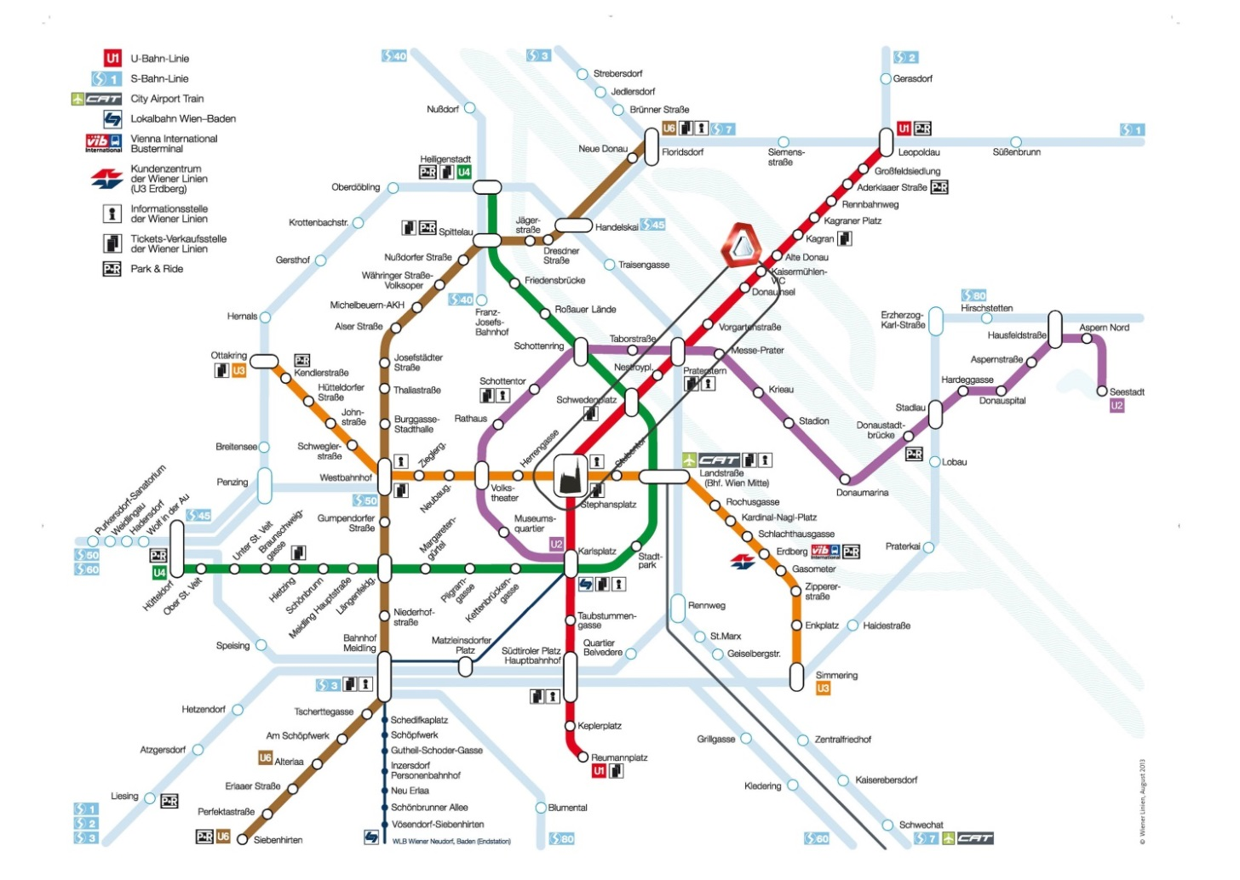

CATERING ARRANGEMENTS

Lunches are included in the meeting arrangement for the days of the Conference.

A festive dinner will be organised on 26th November in Wiener Rathauskeller - Rathausplatz 1, A-1010 Wien (http://www.wiener-rathauskeller.at/de).
This event is opened to participants who paid the dinner fee and all assisted delegates.
Coaches will pick up participants from the different hotels (NH 19:00/Arcotel 19:10) and bring them back after the dinner (22:30/23:15/24:00).

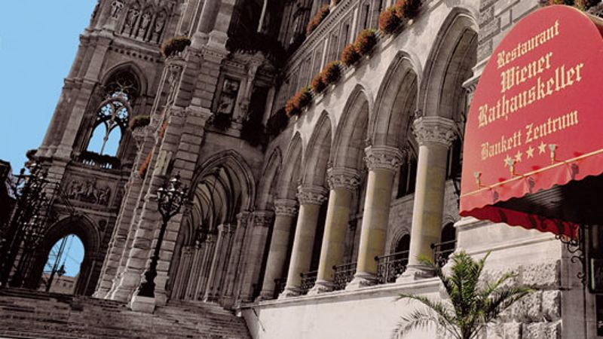

The "Tarragona" restaurant in NH Hotel Danube City can serve up to 150 people. Tarragona serves an International cuisine combining Austrian tradition and Spanish lifestyle. The average price of a meal is16.00 euros.

The restaurant provides an a la carte service and can serve vegetarian dishes. All major credit cards are accepted.

Opening hours:
Earlybird breakfast: Monday - Sunday, 5:30 am - 6:30 am
Breakfast: Monday - Saturday, 6:30 am - 10:00 am. Sunday, 7:00 am - 11:00 am
Lunch: Monday - Sunday, 12:00 pm - 2:00 pm
Dinner: Monday - Sunday, 6:00 pm - 11:00 pm (kitchen closes at 10:30 pm)

Bar: Open daily from 8:00 AM to 1:00 PM

OTHER RESTAURANTS IN VIENNA

Vienna’s eateries – ranging from the typical Viennese “Beisl” (tavern) to the luxurious gourmet temple - offer the entire spectrum of regional and international delights to please the palate. A wide range of possibilities is listed here : http://www.wien.info/en/shopping-wining-dining/restaurants

EMERGENCY CONTACT NUMBER

The European emergency number 112 is not the only emergency number in Austria.

Alongside 112, the following emergency numbers are available:
122 - fire brigade,
128 - gas-related emergency,
133 - police,
140 - mountain rescue,
141 - doctors,
142 - telephone counselling,
144 - rescue/ambulance,
147 - emergency services for children and young people.

For disabled people, separate numbers (e.g. 0043800133133) are reachable via SMS or fax.

It is possible to call 112 from a mobile phone even without a SIM card.

112 calls are answered within 10 seconds.

Calls can be answered in German and, in large cities and tourist areas, also in English.

The 112 operator can detect the location of the caller within 10 minutes.

MAPS

